Project Design Phase-II
Technology Stack (Architecture & Stack)

Date | 19 February 2026
Team ID | LTVIP2026TMIDS24859
Project Name | Calculating Family Expenses using Service Now
Maximum Marks | 4 Marks

Technical Architecture:
The Deliverable shall include the architectural diagram as below and the information as per the table1 & table 2

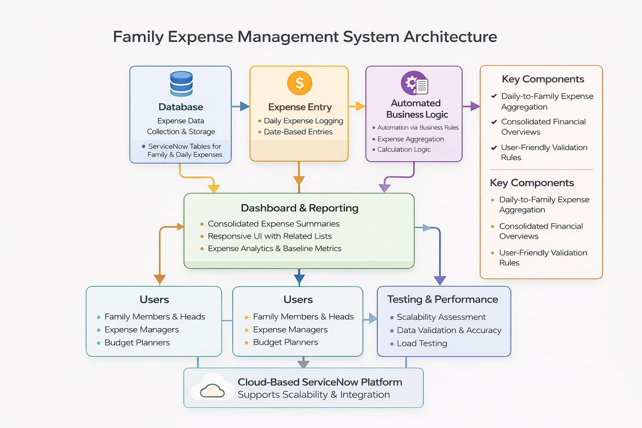

Table-1 : Components & Technologies:

S.No | Component | Description | Technology
1. | User Interface | Web-based forms and lists for entering, viewing and managing family and daily expenses | ServiceNow UI (Forms, Lists, Related Lists)
2. | Application Logic-1 | Expense data validation, auto-numbering, and table-level processing | ServiceNow Table Configuration, Field Attributes
3. | Application Logic-2 | Automated aggregation of daily expenses into family-level records | ServiceNow Business Rules (Serverside scripting)
4. | Workflow / Relationship Logic | Logical linking of daily expenses with family expenses for consolidated views | ServiceNow Table Relationships & Related Lists
5. | Data Source | Structured expense data entered by users | ServiceNow Custom Tables (Family Expenses, Daily Expenses)
6. | File Storage | Secure storage and management of expense records | ServiceNow Cloud Database

Table-2: Application Characteristics:

S.No | Characteristics | Description | Technology
1. | Open-Source Frameworks | The solution does not rely on open-source frameworks; it is built using native ServiceNow platform features. | ServiceNow Platform
2. | Security Implementations | Role-based access control ensures that only authorized users can create, view, or modify expense records. User actions are logged for accountability | ServiceNow Security & Access Control
3. | Scalable Architecture | The cloud-based ServiceNow architecture supports scalability, allowing the system to handle increasing numbers of users and expense records without performance issues. | ServiceNow Cloud
4. | Availability | The application is accessible at all times through the ServiceNow instance, enabling continuous expense tracking and review. | ServiceNow Platform
5. | Performance | Optimized form loading and efficient business rule execution ensure smooth performance even as data volume grows. | ServiceNow Platform

